Beginners Vinyasa Flow Class

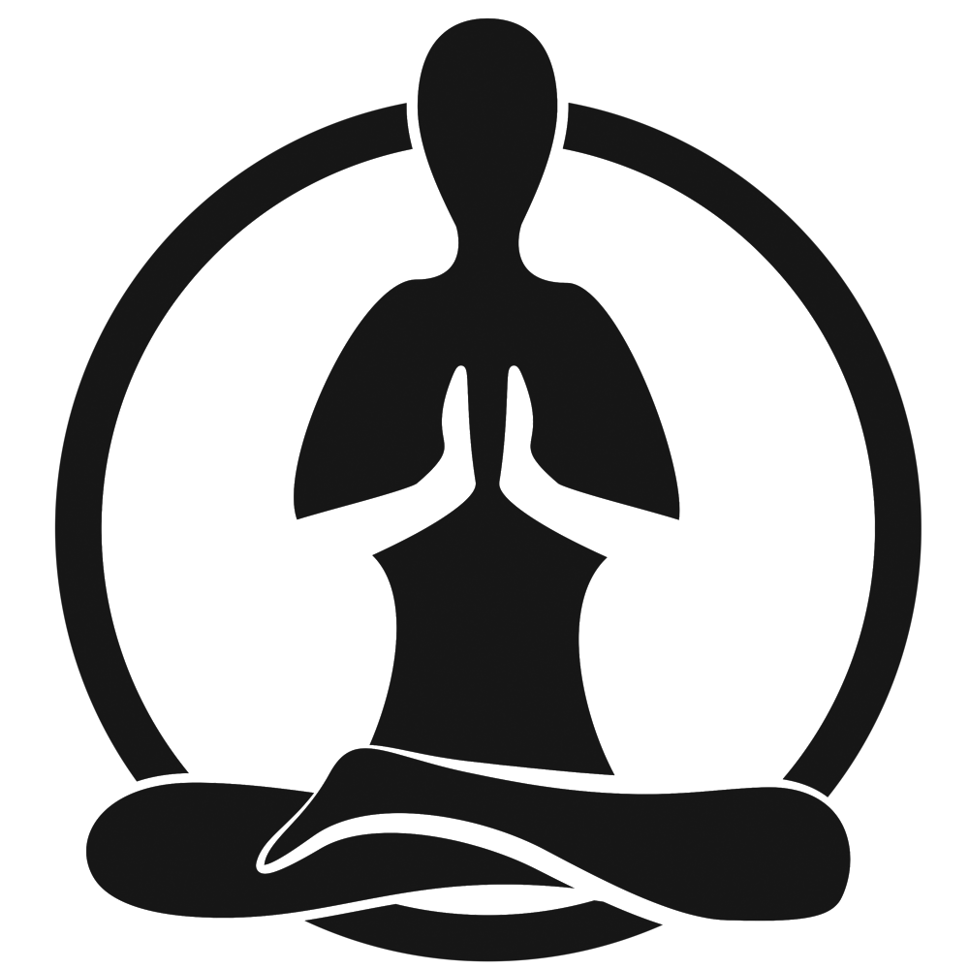

Class 2
Janet Hanspal
NewMoi

2nd class - Beginners Vinyasa Flow Class 2nd Class – 1 hour
Lesson 1 - Learning ‘Sun Salutations’ from mat position to Standing Poses.
Reminder on Ujjayi Breathing - **MOVE TO YOUR OWN BREATH NOT NEIGHBOURS**
Revision on Lessons 1, 2, 3 & 4 & questions
- CHILDS POSE - Settle mentally and into the mat, relax and concentrate on your breathing, stay here for around 1-2 minutes.
- TABLE TOP, COW, CAT, DOWN WARD FACING DOG - ‘Home Base’!!
- Push down into a HIGH PLANK
- Move into CHATURANGA elbows back on Knees or Toes.
- Move into COBRA, keep elbows bent.
- Back to TABLE TOP into DOWNWARD FACING DOG, move around and settle in relax back into your ‘home base’!!
- Step into RAGDOLL and relax
- Walk feet inwards touching your toes, FORWARD FOLD and raise up stretch to sky hands to heart, into a MOUNTAIN pose, clasp hands together except index fingers and stretch to one side, into an EXTENDED MOUNTAIN pose, return to centre and repeat other side.
- Move into a EXTENDED MOUNTAIN with a BACK BEND to MOUNTAIN pose
- FORWARD FOLD to HIGH PLANK onto tip toes into UPWARD FACING DOG Arms straight, move back to DOWNWARD FACING DOG and settle in relax.
- Step in half way forward fold lift to the sky into CHAIR POSE Move shoulders away from ears, forward fold, half way, step back into HIGH PLANK, into UP FACING DOG into DOWN FACING DOG
- THREE LEG DOWNWARD FACING DOG (RIGHT HEEL TO SKY) , R Knee to nose, back, R Knee to Right elbow, back, R knee to left elbow, back, step in with R leg to CRESENT LUNGE (DROP on Knees if needed) relax shoulders reaching hands to sky,
- Move into WARRIOR 2 check you can see big toe
- Into REVERSE WARRIOR Wrap arm around the back if required
- Into EXTENDED RIGHT ANGLE, bend front knee, rest elbow on knee, to floor or rest on a block
- Back to HIGH PLANK, CHADERANGA, UP DOG, DOWN DOG reset
Repeat on L side

Lesson 2 – Learning Standing Poses
- DOWNWARD FACING DOG, into CHILDS POSE to reset
- Into seated position, feet together and relax, hinge forward hands on feet or forward and stretch
- HIGH PLANK and move into R SIDE PLANK on knees or toes, into CADERANGA, UP DOG, DOWN DOG.
- FORWARD FOLD half way, extend lift arms up to sky hands to heart.
- Into CHAIR POSE,
- Move into a R WARRIOR 3, toes point down drop right hip, drop to HALF MOON using block for this section
- Stand to Mountain to Extended Mountain stretches L & R
- MOUNTAIN move into R TREE POSE – using options for foot placement.
- FORWARD FOLD, HIGH PLANK, CHADERANGA, UP DOG, DOWN DOG or CHILDS POSE, reset in home base
- R PIDGEON Pose, rest front knee or hip on block if needed back up to R 3 LEG DOWNWARD FACING DOG bending knee opening hip to release blood flow
Repeat on L side
Lesson 3 - SAVASANA
This is a restorative asana that is a key component of yoga. It usually follows Vinyasa or is practiced near the end of a yoga session. See below for the Poses we will be practicing at the end of each lesson.
Janet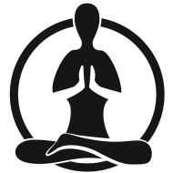Hanspal

Side Plank Forward Fold Chair Pose
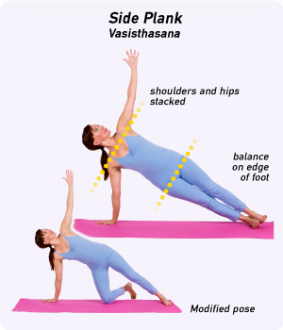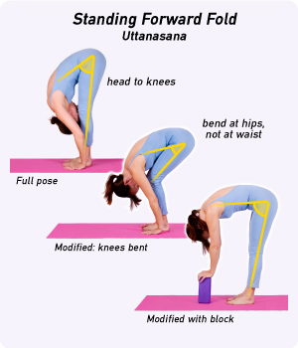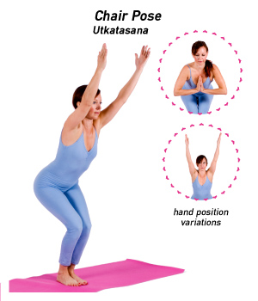
Warrior 3 Pose Half Moon Pose

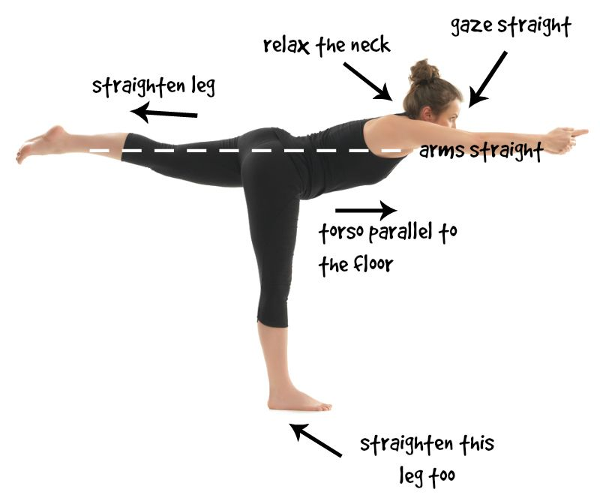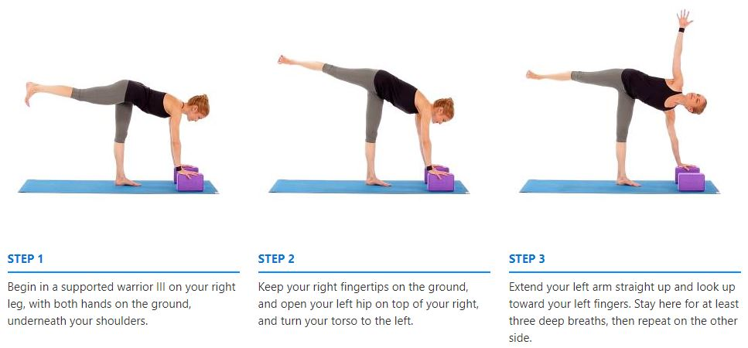
Tree Pose Pigeon Pose
