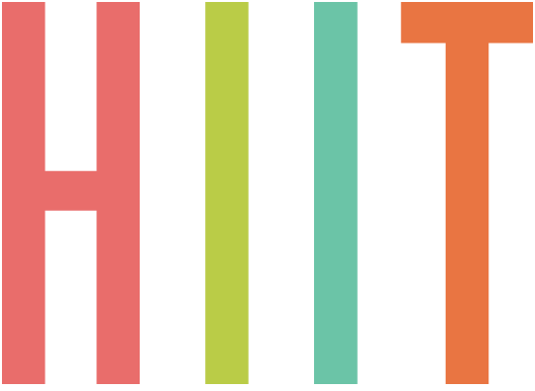
12 exercises – 2 times – 60sec work – 30sec rest

- SHUFFLE SHUFLE TOUCH TOES
- SQUAT WALKS
- FORWARD REVERSE LUNGES ON LEFT SIDE CHANGE TO RIGHT SIDE ON 2nd SET
- SUMO LOW SQUAT – DOUBLE, DOUBLE, PULSE
- WALKOUTS – UP TO TOUCH TOES, REPEAT
- PLANK WALKOUTS
- WALKOUTS – 4 SQUATS AT TOP, REPEAT
- CLIMBING BEASTS ON KNEES OR TOES
- FULL BODY CRUNCHES REACHING TO TOES/FLOOR, FEET ON OR OFF FLOOR
- ON BACK OPP KNEE BEND, STRAIGHT LEG LIFT WITH BUM OFF FLOOR, HIPS TO CEILING, CHANGE SIDES ON 2nd SET
- ON BACK OPP KNEE BEND, STRAIGHT LEG UP TO CEILING, CRUNCH UP REACHING TOWARDS THE TOES, CHANGE SIDES ON 2nd SET
- PRESSUPS – WIDE (CHEST) TO NARROW (TRICEP) ALTERNATING ON TOES OR KNEES

