APRIL TOPIC

Interesting. ......

Since starting to teach Piyo and as a teacher learning more about Yoga, I have realised the importance of improving your Flexibility, Stretching, and increasing your Core Strength. It also helps you learn how to use effective breathing techniques, which not only helps your mind but your overall performance.   
Having taught ‘Fitness Classes’ for 27 years. ... I have encountered many various workouts, but since teaching Piyo, which incorporates Yoga based moves and techniques, I have been amazed at the results my clients have seen. The feedback I get from them is they say how much their bodies have changed. Not only in their strength (upper body and Core) but how has the stretching made them so more flexible. They tell me how they are achieving far more within their fitness classes in general, and how amazed they are from the change in their body shape.   
I have quite a few Runners and cyclists in my classes who have been told to improve their core strength, increase their flexibility and stretching due to injuries. All these clients have said they are now getting fewer injuries and they are finding they are performing more effectively within their sport.  
So treat yourself to a Piyo or a Yoga class....your body, muscles and mind deserve it. ....  
Janet

[[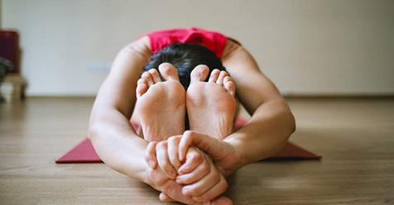](http://yogaforrunnershq.com/Blog?post=5-ways-how-yoga-will-improve-your-running#.WEUUdnOitYk.facebook)](http://yogaforrunnershq.com/Blog?post=5-ways-how-yoga-will-improve-your-running" \l ".WEUUdnOitYk.facebook" \t "_blank)

[5 Ways How Yoga Will Improve Your Running - Blog](https://l.facebook.com/l.php?u=http%3A%2F%2Fyogaforrunnershq.com%2FBlog%3Fpost%3D5-ways-how-yoga-will-improve-your-running%23.WEUUdnOitYk.facebook&h=ATNSBGlWsxwzcLW9iTDs1_0rO2RqIxtPaDUh_-kG8X7giWS1t5yx4JiIYOz-bKxewPZWoxsEk-pbl_1bFf4X7OpYUZ04KkNFFmWwf3kt2llzuQgzOAB8M-g21yK8zzppNNTVS8iGLZ0&enc=AZPFrSADAXbWioHlOVZiJgeQUh4lOhs7yvL5-u42aM6aG25pacwfIPPWZrxTcg-7KpOdfSfRg9rGPYFVJTY0kDOG3GxYmxGw8-0ldxDIf0gj67P6OnFdD7EbKY29E6MbtSlRA7NBcfn1QyhyM75gnR7mn8tYV8pY_4n_HY1_uc-QKHd3t621hLdww7vMknN47pPl-cnfAaITywEJAiVd1PiB&s=1)

I'm 19 kilometers into a half marathon. It is raining like crazy. It feels like I am floating towards the finish line at an incredible pace. I feel AWESOME. 2km later I had my medal in hand and a personal best of 1:35:05. But it didn't start out like…

YOGAFORRUNNERSHQ.COM