February's Topic...

The Menopause

Having been though this myself for 8 years!! And come out the other side, I only know too well what this does to your body. Weight gain is a one if the symptoms that can affect you. The weight that you gain appears around your stomach and thighs, and can be very stubborn to shift. One thing I would advise anyone who is menopausal is too exercise and not to give into the tiredness that you also feel. Including a exercise regime into your lifestyle will help you to feel more energised, and keep the weight gain in check. Along with a healthy eating plan, this will help you to cope better with the Menopause and come out the other side feeling like you’re of self again.   
Remember. It’s not the end of your youth, but the beginning of a whole new chapter of your life and from my own experience it's the best chapter yet of my life story. ....

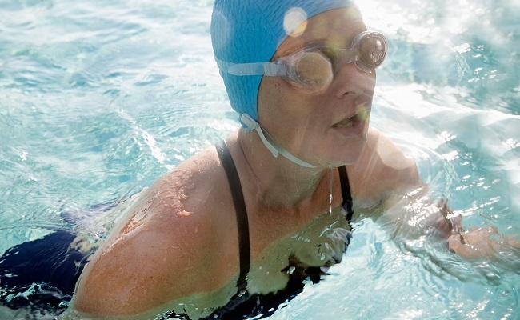

[6 Workout Mistakes Women Make When They Hit Menopause](https://l.facebook.com/l.php?u=http%3A%2F%2Fwww.prevention.com%2Ffitness%2Fworkout-mistakes-after-menopause&h=ATPiO5DlJxOsZAg5CASB1FvDvdeUaJzCVxZ5-MNx4Y4FFCxsk01NV-QLoxcNWTjSG8SaWL_mtGO7HKFwahzd8s9cWAGGp3-xe0MvPkHajaE5Zxtj3QBWa-gYkKSBF7MtSadmTrv7oFU&enc=AZNUzlPDp8L-m9ssEvokDUH8SbyISMzdKyibcfNIv-vKGFjbC1gPpj_Usqv9COOJk5pKWCd1n6x0fOqQ4X5EwKOVmWMeTrPKVcaUw0x9BuSONgyxky-N7JioMqj93ACTJEIV5R2SV1Ca6LA8pvSY6WaVUb8Jv4KLF-f_9J0_V9jVBmTBGms9npDvhh6P74qsI4_dnhGdd1nnIp-AyT2DMfTM&s=1)

These 6 workout mistakes you make after menopause could be causing your weight gain.

PREVENTION.COM