Total Body Cardio Workout 35min
40 sec’s work - 20 sec’s rest
Repeat each exercise twice
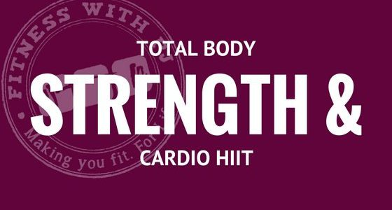

4min warm up 30sec each exercise 2 times though
- Boxer Shuffle side to side
- Kick backs high or low
- Squat reaches
- Jumping Jacks high or low impact – arms straight and high over head
HIIT Workout 15 exercises repeated TWICE !!! (BUT…Start once and work up to doing twice)
- High Knees or Jog on spot
- Mountain Climbers on toes or knees FAST… Stay low, knees to chest
- Basic Squats or Squat Jumps
- Press-ups on knees or toes
- Reverse Lunges or Lunge Jumps
- Ab Crunch - knees bent reach for knees or take one leg stretched out reach for toes.
- Squat Plank – Squat in and out (Knees to chest) and 2 jacks repeat or stay on knees and jack out L side then R side
- Glut Bridge – Lift Bum off the floor with one leg stretched out repeat on the other side
- Sit-ups knees bent or legs straight, stretched out arms over head reaching down over head to knees or toes
- Walk out Planks (From forearms to standard plank) on knees or toes
- High fast knee lifts reaching over head ‘Climbing a rope’
- Burpees + 2 press ups, repeat
- Shuffle side to side touching floor if you can!
- Walkout with straight or bent knees 4 triceps press ups, repeat
- Runners Lunge fast or slow R to L alternate staying as LOW as you can

