**Weight Loss & Exercise**

**‘Myths and Reality’**

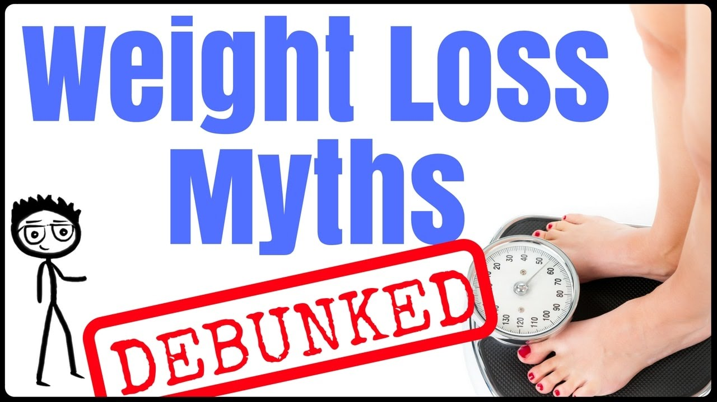

I am often asked by my clients “My body measurements are going down, my clothes feel loser and I am looking more toned so why am I not losing scale weight?”

Losing weight is one of the hardest things as adults we face when as we get older. Why? I hear you ask, that’s because we have had years of building up bad habits and creating cravings for food that contains sugar and unhealthy fats, and enjoying the odd alcoholic drink !!. All of us need to acknowledge that having all of these things in moderation is fine and you should treat yourself now and then, but reducing the amount of calories and eating more of the good stuff is also very important.

Finding that balance is not easy, and I am going to try to give you a few tips and some information to help you. Attending a ‘Slimming’ club will help you start to change your habits, but think on…. In the long term ultimately YOU need to change. It is often the case people will reach their target weight and once they go alone they pile this weight back on and sometimes even more, otherwise known as ‘Yoyo’ dieting.

Changing the way you think about food, introducing exercise into your life, and setting realistic long term goals is not easy. But having been though this myself I know that taking it one step at a time and setting short term achievable goals will start you feeling… ‘Actually I can do this!’

I always tell my clients do not expect results overnight, start making changes into your life style now but be realistic and that way you are NOT setting yourself up to fail.

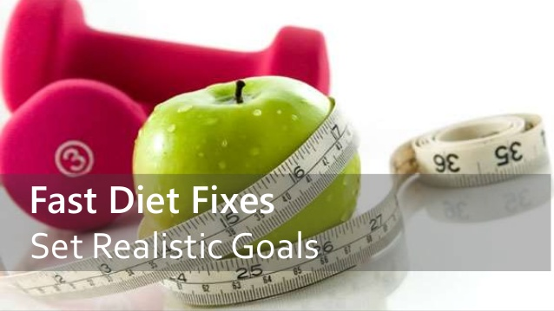

**LOSING WEIGHT, BURNING FAT AND EXERCISE**

Once you have decided to start to change your lifestyle and change your eating habits, another factor is ‘Exercise’. This is a major part of a healthy lifestyle but can be hard to begin with.

There are so many myths, half-truths, and downright falsehoods about exercise—especially its effect on weight loss. Follow any of this inaccurate advice, and you may wind up wasting time, energy, and money, or even injuring yourself.

The average person with an average amount of fat to lose will typically lose it at a rate of 1-2lbs per week without a problem.

So the clear message here is that in most of the cases where you see NO weight loss for an extended period of time and think it’s because “muscle weighs more than fat” and you’re really losing fat but just simultaneously gaining an equal amount of muscle at an equal rate… you’re probably wrong. And by “probably,” I mean you’re wrong 99% of the time. In reality, the reason why your weight isn’t decreasing is because you’re just failing to lose fat it is as simple as that.

**The**[**caloric deficit that is required for fat loss**](http://www.aworkoutroutine.com/how-to-lose-fat/)**to take place. Eat less calories, burn more calories, or do a combination of both.**

**BUT DO not despair**…….I am going to try and answer some of the most common questions with some advice and information that will hopefully give you some answers.

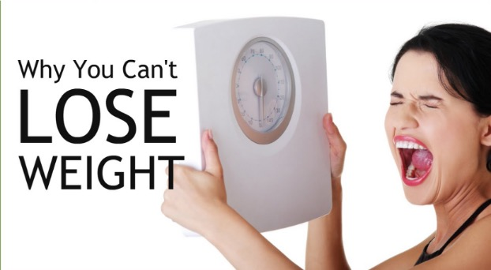

**MUSCLE “WEIGHS” MORE THAN FAT.**



**Reality:** A pound is a pound is a pound—unless you’re defying the laws of physics. No substance weighs more then another one unless it actually weighs more. Simply put: One pound of fat weighs the same as one pound of muscle. **The difference** is that fat is bulkier than muscle tissue and takes up more space under the skin. In fact, one pound of fat is roughly the size of a small grapefruit; one pound of muscle is about the size of a tangerine. But that tangerine is active tissue, meaning that it burns more calories at rest than fat does.

**WEIGHT TRAINING CONVERTS FAT TO MUSCLE**

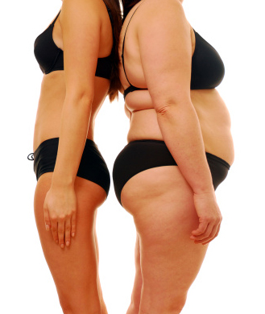

**Reality:** This is physically impossible. Fat and muscle tissue are two completely different substances. Exercise such as strength training will help to build muscle, which encourages fat loss by increasing your resting metabolism so you can burn more calories throughout the day. To get a lean look, you need to build muscle through weight training while simultaneously losing fat—but one doesn’t magically become the other.

**LIFTING HEAVY WEIGHTS WILL CAUSE WOMEN TO BULK UP.**

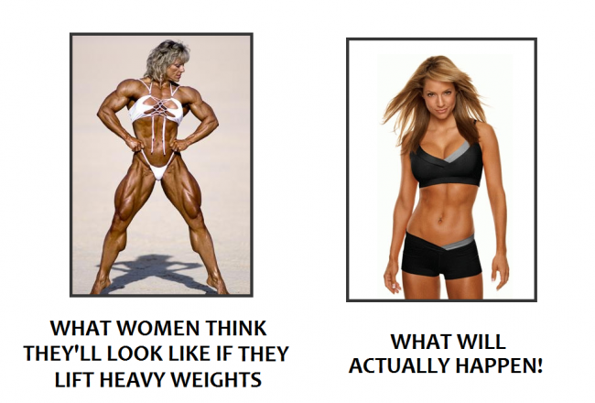

**Reality:** We just don’t produce enough testosterone, the male sex hormone that spurs muscle growth, to get big, meathead muscles. Lifting weights sometimes gets the blame for adding bulk because if you haven’t yet shed extra body fat, it can give the illusion that you’re getting larger, but muscle boosts your metabolism, so don’t be afraid of those 20-pound dumbbells (or at the very least, work your way up to them).

**YOU CAN WALK OFF EXTRA POUNDS**.



**Reality:** Although walking is good exercise and most of us don’t do enough of it, if you want to lose a noticeable amount of weight, it’s not the best method since it’s low intensity and doesn’t burn a lot of calories during or afterward. To substantially shrink your belly and keep it flat, you want an integrated approach of strength training, cardio (preferably intervals), and a calorie-controlled diet. Adding in a few extra miles on your feet daily as one part of an overall weight-loss plan is good and good for your health, but that alone probably won’t lead to significant results on the scale.

**YOU’LL BURN MORE FAT ON AN EMPTY STOMACH**.



**Reality:** The body torches about the same amount of flab whether or not you nosh before a workout but your body also needs fuel in order to perform at its best, build muscle, and burn calories, so you should always eat something light about 30 to 45 minutes before exercise such as a protein shake, yogurt, or a piece of whole-wheat bread with peanut butter.

**YOU SH** **OULD DO CARDIO AND STRENGTH ON SEPARATE DAYS.**



**Reality:** There is no scientific reason to keep the two isolated, and you up your chances of hitting your goal—whether its health, strength, or a pants size—by combining them. And then there’s that whole time-saving perk. Doing a HIIT or Circuit workout, where you alternate between combo exercises (squat to row or press, for example) and short, high-intensity cardio bursts such as Knee lifts Jumping Jacks etc. Going back and forth like this with minimal rest builds strength and gets your heart rate up even more than a typical half hour on the same exercise at moderate pace.

**LONG AND SLOW CARDIO TRAINING BURNS THE MOST FAT.**

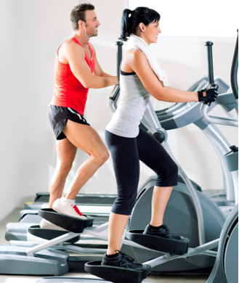

**Reality:** While it’s true that lengthy (ENDURANCE), slow workouts will use up more fat for energy, they’re not the ONLY way to go for fat loss; instead focus on the total calories burned during *and after* your workout. Ditch devoting 75 mind-numbing minutes to a slow trod on the treadmill, and do interval training or higher intensity interval (HIIT) exercise for half—or even a quarter—of that time, which burns more calories at a faster rate and keeps your metabolism revved post-gym session.

**IN CONCULSION:**

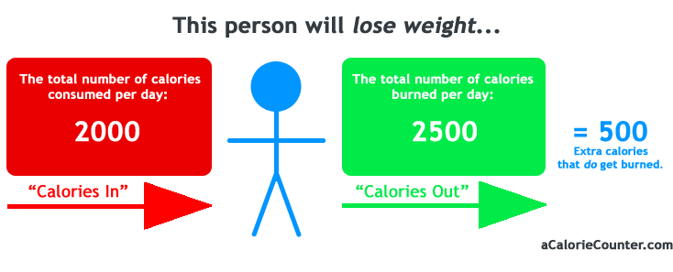**Losing weight (burning fat) is often overcomplicated and there are a lot of falsehoods out there. Simply put, if you consume less calories than you burn (called a caloric deficit), you will lose weight, adding exercise on top of this will increase the amount of calories you burn further adding to the caloric deficit. In order to lose fat this deficit must be maintained over time using a healthy lifestyle involving both good eating habits and regular exercise. Consistency is key.**