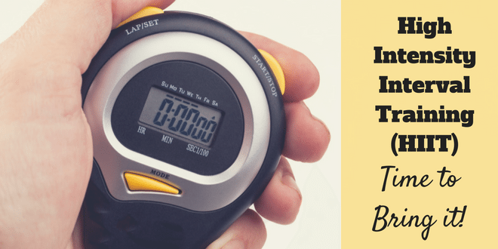
July 2017 - HITT
Fat Burning Cardio Workout 40min
20 sec’s work - 10 sec’s rest
Repeat 6 sets of each exercise

4min warm up 30sec each exercise
- Boxer Shuffle side to side
- Bowlers side to side
- Walk down to high plank
- Kick backs high or low
- Basic squats
- Lunges L&R
- Alternate high knee lift - high or low impact
- Jumping Jacks high or low impact – arms straight and high over head
HIIT Workout
- Forward broad jumps + 2 Jumping Jacks turn around and repeat
- ‘Pop’ Squats like Reach downs but with a jump in-between each one
- Burpees + 2 front kicks R/L
- 3 Switch Foot Jumps + Reverse Lunge on 3rd Jump
- Low slide Squat Jump L to R – TIP Stay low in the knees
- Flutter kicks – Lie on back shoulders off the floor and engage abs. Legs straight out and lift R/L as fast as you can BUT in in full range of movement.
- Static Squat & Step Back/Lunge – Stay low in Squat position
- Walk outs + 2 press ups
COOLDOWN
- 5 min to reduce heart rate slowly and safely, followed by Stretches

