Beginners Vinyasa Flow Class

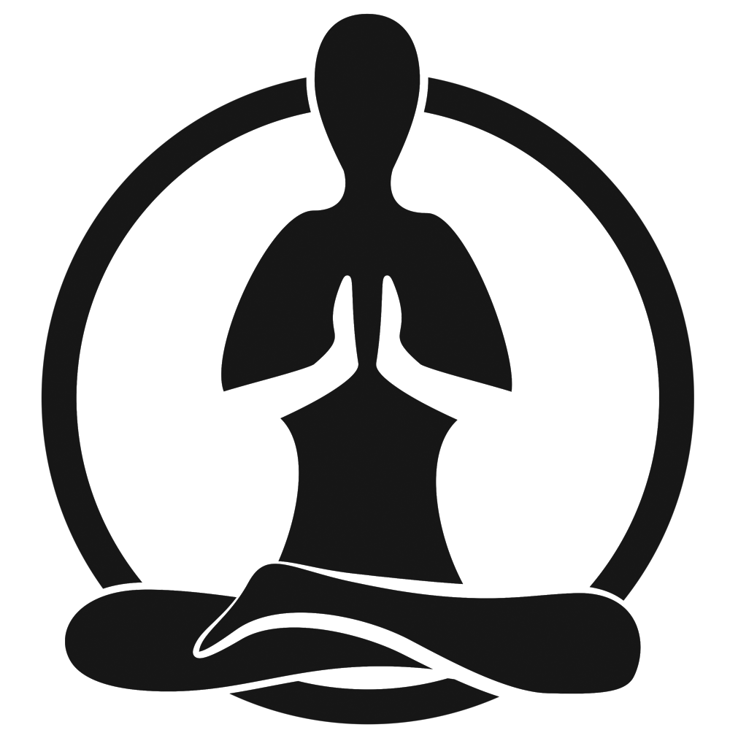

Class 1
Janet Hanspal
NewMoi

1st Beginners Vinyasa Flow Class 1st Class – 1 hour
Lesson 1 - Learning ‘Sun Salutations’ from mat position
We will use Ujjayi Breathing - This technique helps calm the mind but also energises the body too. When practicing Ujjayi, you completely fill your lungs, inhaling though your nose, while slightly contracting your throat, and breathe out to start with an open mouth, learning to close the mouth eventually. This breathing technique is used throughout Ashtanga and Vinyasa yoga practice
**MOVE TO YOUR OWN BREATH NOT NEIGHBOURS**
- CHILDS POSE – Brings knees wider than your hips, touch your big toes together, relax your hips down towards your toes.
- Settle mentally and into the mat, relax and concentrate on your breathing – (Ujjayi breath) Stay here for around 1-2 minutes.
- TABLE TOP, fingers wide, moving into COW drop belly, moving into CAT Spine to sky, drawing chin to chest.
- DOWN WARD FACING DOG - ‘Home Base’!!
- Move knees, hips and settle into the pose, press into finger tips
- Push down into a HIGH PLANK…. Lower slowly to mat as you lower down drop onto your belly (DROP on Knees if needed)
- Move into CHATURANGA elbows back on Knees or Toes.
- Move into COBRA Hands by shoulders, elbows point towards the back, lift chess towards the sky, press tops of feet into mat, hips & Pelvis on the floor … Keep elbows bent.
- Back to TABLE TOP into DOWNWARD FACING DOG, move around and settle in relax back into your ‘home base’!!
Repeat 3 times
Lesson 2 - Learning ‘Sun Salutations’ into ‘Stretch Poses’
- Step into towards your hands, feet hip distance or tad wider, Bend Knees, forward fold and cross arms into RAGDOLL and relax move side to side allow back to drape downwards and relax the shoulders and neck.
- Walk feet inwards touching your toes, bend knees, lift half way up, lift tailbone to sky and relax, bend knees and raise up stretch to sky hands to heart, reach back up to sky into a MOUNTAIN pose, clasp hands together except index fingers and stretch to one side, into a EXTENDED MOUNTAIN pose, return to centre and repeat other side.
Lesson 3 - Learning ‘Sun Salutations’ from a standing position
- Lift arms up to sky move into a EXTENDED MOUNTAIN with a back bend, returning to MOUNTAIN pose
- Forward fold bend knees lift tailbone, forward fold navel to spine, lift to half way and back to HIGH PLANK onto tip toes bend knees drop downwards into UPWARD FACING DOG Arms straight, Hips and Pelvis lifting away from the mat (DROP on Knees if needed)
- Move back to DOWNWARD FACING DOG move around and settle in relax.
Repeat 3 times.
Lesson 4 (Class 1 or 2) - ‘Sun Salutations’ from a standing position with ‘Standing Poses’
- Step in half way forward fold lift to the sky into CHAIR POSE Move shoulders away from ears, forward fold, half way, step back into HIGH PLANK, into UP FACING DOG into DOWN FACING DOG
- THREE LEG DOWNWARD FACING DOG (RIGHT HEEL TO SKY) , Knee to nose, back, Knee to Right elbow, back, knee to left elbow, back, step in to CRESENT LUNGE (DROP on Knees if needed) relax shoulders reaching hands to sky,
- Move into WARRIOR 2 check you can see big toe
- Into REVERSE WARRIOR Wrap arm around the back if required
- Into EXTENDED RIGHT ANGLE, bend front knee, rest elbow on knee, to floor or rest on a block
- Back to HIGH PLANK, CHADERANGA, UP DOG, DOWN DOG reset
Repeat on L side
Lesson 5 - SAVASANA
This is a restorative asana that is a key component of yoga. It usually follows Vinyasa or is practiced near the end of a yoga session. See below for the Poses we will be practicing at the end of each lesson.

Table Top, Cow and Cat Pose sequence A Ragdoll Pose Forward Fold
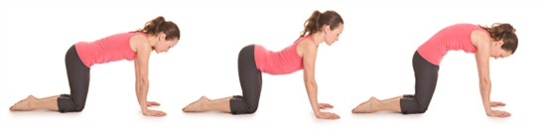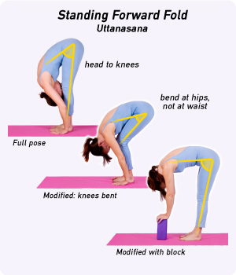

Difference between a Cobra Pose and an Upward Facing Dog Mountain & Extended Mountain Poses
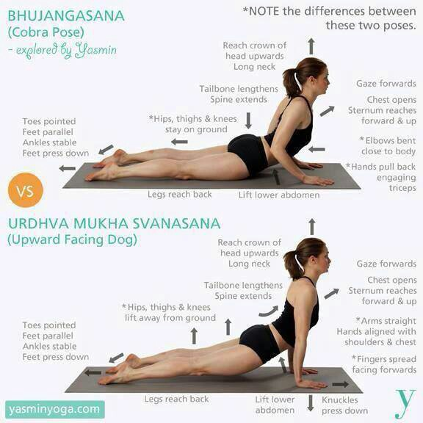

Downward Facing Dog - Using Block Good and Bad Practice!!
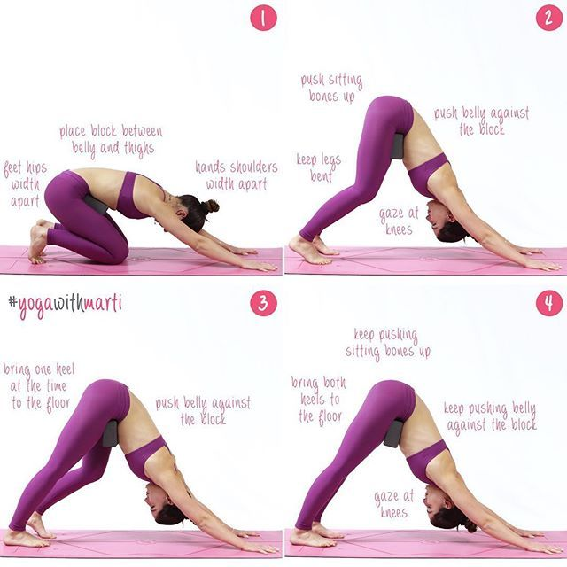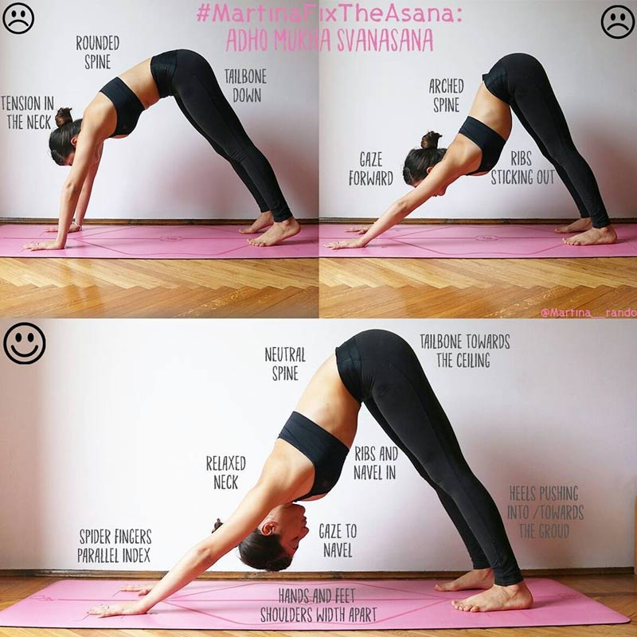

Chaturanga
Modified version on knees – Standard Knee Plank Full Chaturanga
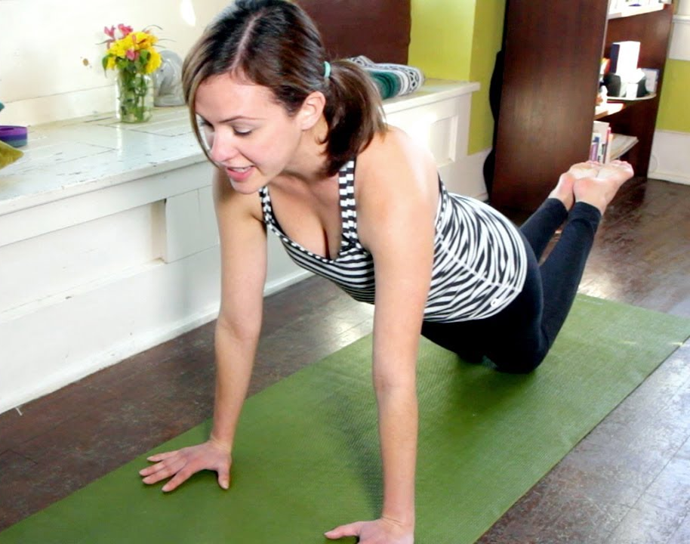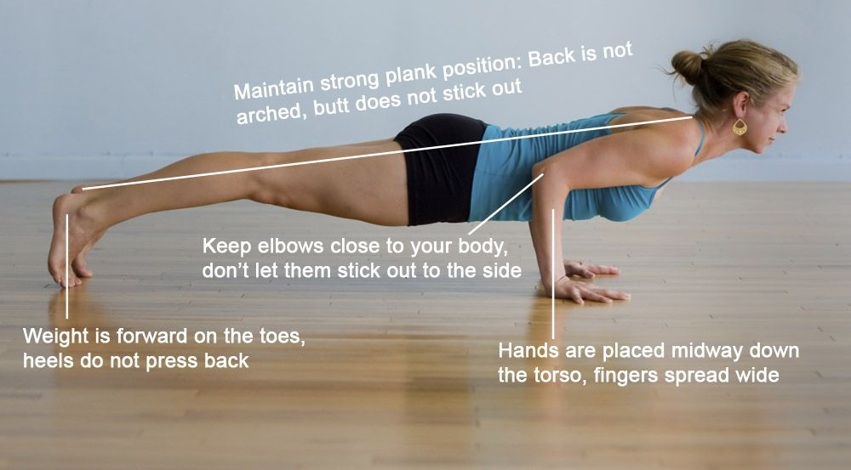
Chair Pose Three Leg Downward Facing Dog
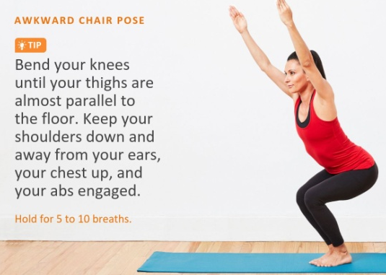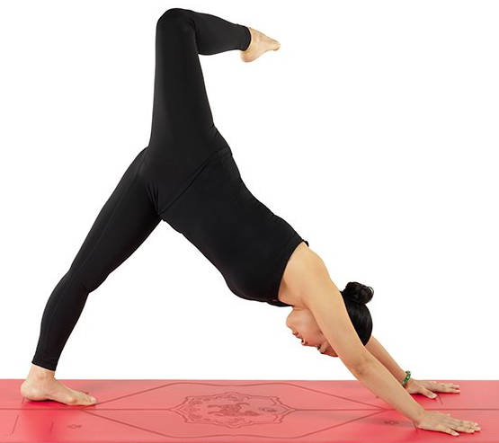

Crescent Lunge Pose Warrior 2 Pose
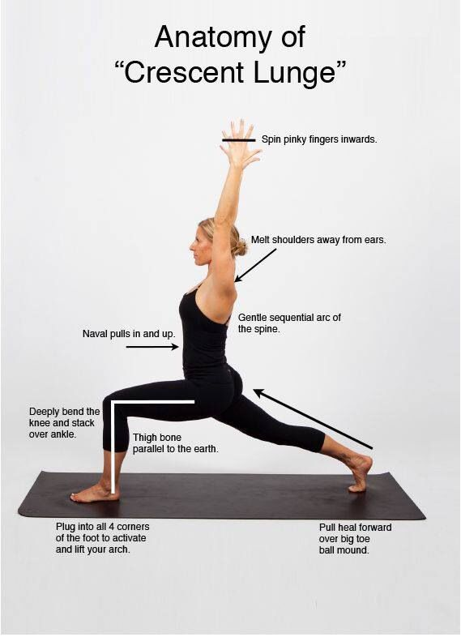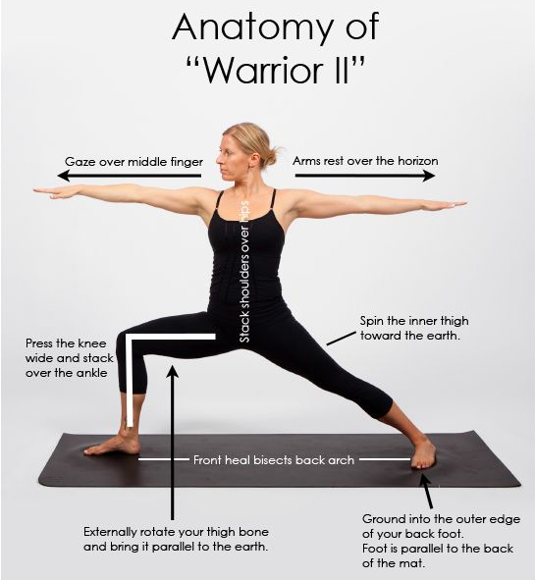
Reverse Warrior Pose Extended Right Angled Pose
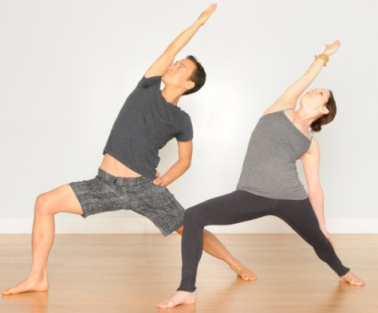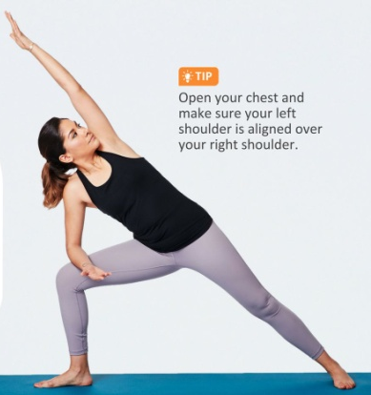
SAVASANA – 5 -10mins
Corpse Pose Stretch for Hip/Adductors Happy Baby Pose Hamstring Stretch
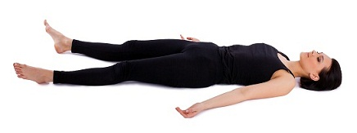
Easy Pose Seated Twist Pose Easy Pose (hands to Heart) – ‘Namaste’
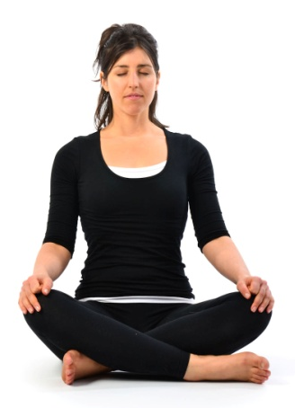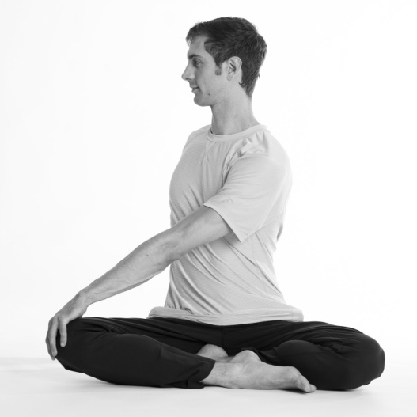 Switch sides

What is ‘Vinyasa Yoga’
Here are 9 reasons why practising ‘Vinyasa Yoga’ will enhance your lifestyle and improve your ‘Health, Mentally & Physically’….
With unfamiliar names like “Ashtanga,” “Bikram,” and “Vinyasa,” it can be hard for beginners to keep all the schools of yoga straight. But if you can remember that Vinyasa means “breath-synchronized movement,” you’ll know everything you need to about this fantastic style.
Whether you’re just starting out with yoga, or you’re looking to try something new, there are tons of great reasons to try Vinyasa—which is one of the most popular styles among people of all experience levels.

1. You stay focused by going with the flow.
You’ve probably heard the phrase “Vinyasa Flow” when referring to this type of yoga. Vinyasa Flow refers to the way this style keeps you moving from asana to asana, linking each pose to an inhale and an exhale.
Instructors keep the flow of movements smooth and continuous, which can help you stay present during the session. If you find your mind wandering off in the down-time between poses or sequences, Vinyasa yoga is for you.

2. It’s all about variety.
Vinyasa has a lot in common with Ashtanga yoga, which also links continuous sequence through the breath. But while Ashtanga uses a proscribed sequence of poses that’s taught the same way in every class, Vinyasa is a lot more flexible.
Instructors are totally free to mix up the order of the poses, or throw in something new and unexpected. This “no rules” approach to yoga means you’ll never fall into the slump that can set in when you repeat the same routine over and over. It allows the instructor to tailor the flow and poses to suit the level of class especially when teaching a ‘Beginners’ class.

3. You can find your perfect yoga class.
Since there are no set-in-stone rules about how to conduct a Vinyasa class, teachers can incorporate whatever they choose into the class—including different styles of yoga, a thematic music playlist, or a relaxing nature soundtrack.

4. It pushes you to your limits.
Though “Vinyasa Flow” might sound easy and relaxing, this style can seriously push your physical limits.
This style incorporates elements from all schools of yoga, so even if you’ve mastered those Iyengar standing poses, you’ll find yourself in all new territory when the instructors throws in a Anusara inversion. You’ll push the limits of your strength, flexibility, and balance with Vinyasa yoga.

5. It gives you great cardio.
Cardio is an important part of any fitness routine. The continuous sequence of Vinyasa yoga is great for getting your heart going, even when the pace is relatively slow. The only ‘break’ you’ll get is in resting poses like Downward Dog, or a Resting Childs Pose, which will lead right into another, more challenging pose.
This style of yoga is great for working up a sweat.

6. Improves Flexibility
Sedentary lifestyles lead to stiff muscles, which are not only uncomfortable but also make it difficult to move. As you indulge in the Vinyasa flow, continuous movements help you stretch each muscle and strengthen it simultaneously. This increases your range of motion as well as mobility. Also, since your breath is in sync with the movement, fresh oxygen fuels and loosens up all the muscles. When the muscles are flexed, the stress is released and reduced from the ligaments, joints, and tendons. This prevents injuries, tears, and muscle pulls.
7. It’s perfect for beginners.
Since Vinyasa is so diverse, it’s easy to find classes tailored specifically to beginners that will still provide a healthy challenge. This style is also a great way to learn the basics of pranayama, or yogic breathing, since the instructor will tell you when to inhale and exhale during each pose.
This style is a great way to learn the skills you need to build a strong foundation for a more advanced yoga practice.

8. Vinyasa is fun!
With the flowing movements and great music usually playing in class, this style feels like a dance! Just about everyone looks super graceful practicing Vinyasa yoga, and there’s no better feeling than seeing yourself flow into the perfect warrior pose in the mirror.
9. The Health Benefits
Vinyasa Yoga is said to work at the physical, emotional, mental, and spiritual levels, thus helping to connect the mind to the body. This helps relieve anxiety and stress. When you mindfully practice Vinyasa Yoga, it allows you to shun the static thoughts running through your mind. As you focus on inhaling and exhaling, your central nervous system is calmed down. It has an extremely positive effect on your being.
When you practice Vinyasa, you are forced to concentrate on your breathing for the duration of your session. This means that you practice with full awareness. The Ujjayi method of breathing, which the Vinyasa Flow adopts, not only allows you to fill your lungs with oxygen to its full potential but also removes toxins. The breathing calms your mind and also reduces the risk of type 2 diabetes, heart diseases, and high blood pressure. Your organs are healed, and they begin to work to their full potential. The heat created in the body while you practice cleans the thick, impure blood and makes it thinner. This helps improve blood circulation throughout the body. Even as you breathe in and out, you eliminate toxins through your breath, thus inducing a total body detox.
With regular practice, you will notice that you get less tired and feel more energized and alive throughout the day, and you will start to sleep better and lose weight.
Janet 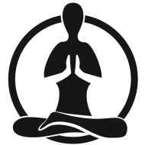Hanspal

