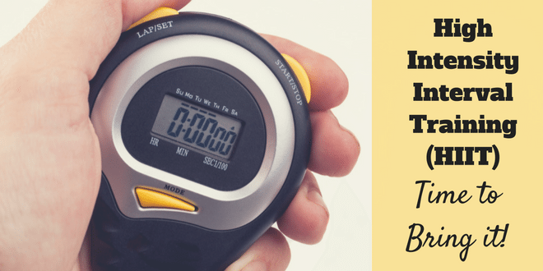
February 2019 - HITT

Low Impact Leg’s & Abs’s Blast Workout
4min warm 30sec on each exercise repeat twice though
- Forward jog and backwards- 4 forward 4 back
- Kick backs
- Basic squats
- Reverse lunge + knee lifts L & R

HIIT Workout 20min
20sec - work / 10sec – rest repeat 4 sets of each exercise
- Wide Sumo Squat Reaches
- Repeater Knee lifts L & R alternate
- Jumping Jack Slow and deep Arms - full stretch up!!
- Sit ups feet on floor
- Knee reaches feet on floor or off
- Reach over’s feet off hands come down to floor
- Squats
- Jogging climbing a rope
- Mountain Climbers
- Single leg reach straight leg in line with bent knee L & R alternate
- Bicycle crunches slow elbow to knee
- Shuffle - Shuffle - tap
- Power Lunges - forward L & R alternate
- Leg extensions slow alternate L & R
- Wide push ups on knees or toes
- Plank walk on knees or toes - forearms to standard plank

