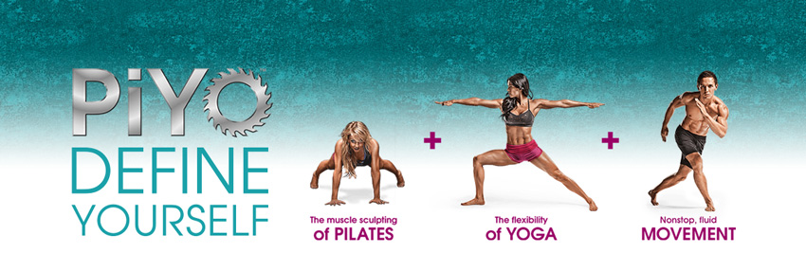
PIYO LIVE Master Class
Date:
Venue:
Instructor:

Piyo is a fusion of Yoga and Pilates, but is also functional strength training for your body. It contains yoga inspired moves with an up tempo pace for serious fat burning cardio, strengthening, and lengthening.
You will begin to develop intense core strength and lean muscle development like in a Pilate’s class, but also the body sculpting and stretching benefits you would see from regular Yoga. Let's not forget the heavy-duty calorie blasting of pure all out cardio!
And the best part about Piyo, is it is completely low impact!

Why take part in a Piyo Live Master class?

There are many moves that are frequently practiced and repeated within each section of a Piyo Workout.
Today we are going to cover 6 of the more commonly used moves.
We will discuss the benefits of performing each of these moves/exercises, and how to align and position your body when executing each of the moves/exercises. I will teach you how to keep safe & using adaptations where needed, listening to your body & using the correct breathing techniques when executing each move. This will ensure you get the best possible results when practising them in your Piyo class.
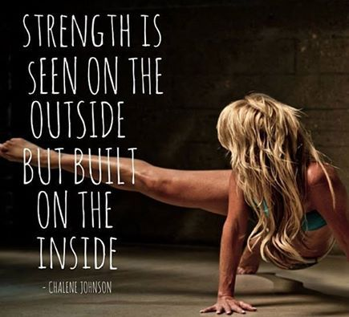

Piyo is performed in 11 sections
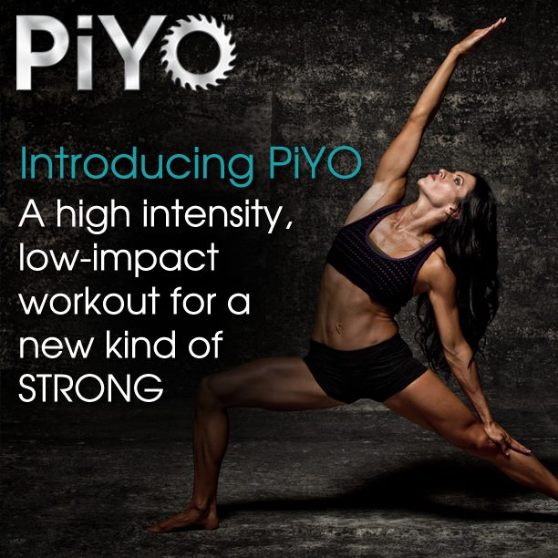

Warm up
Heat Building
Lower Body Workout
Full Body Fusion
Power
Left Flow
Right Flow
Flow Fusion
Core & More
Strength & Stretch
Cooldown
The Moves/exercises you will be covering in today’s Piyo Master Class
Standard Plank/ Forearm Plank
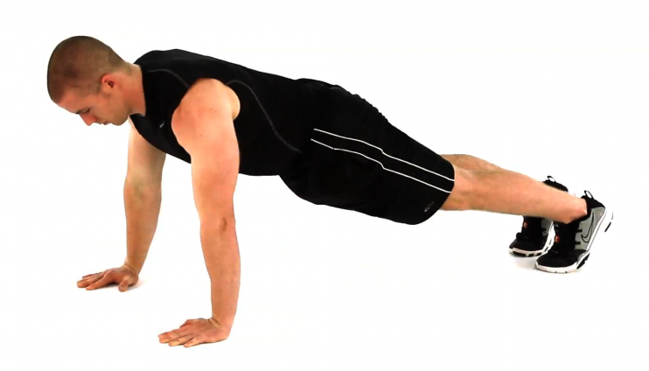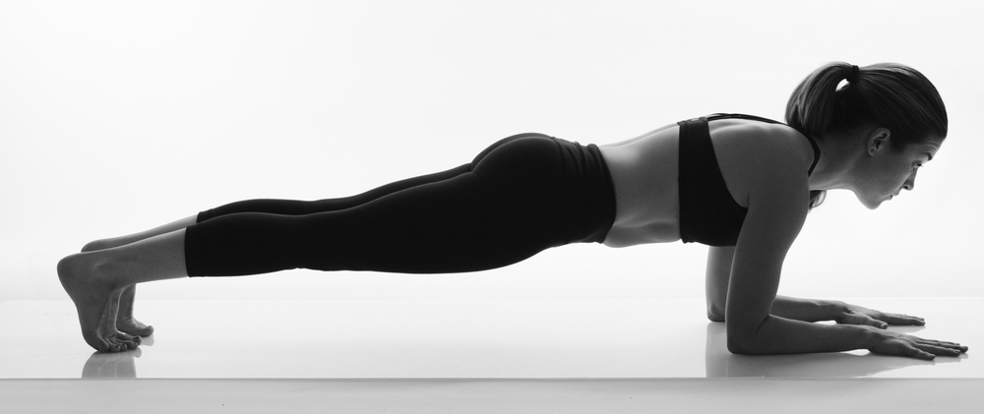

Knee Plank
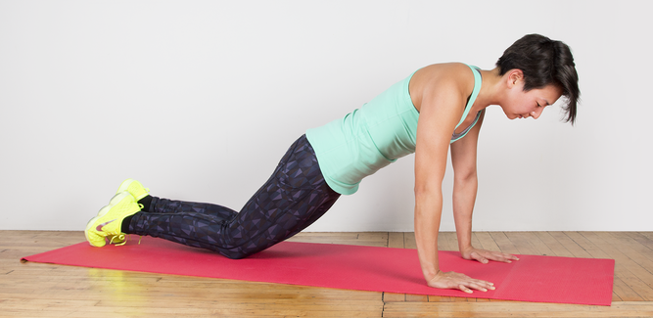

Triceps push up on Toes/knees
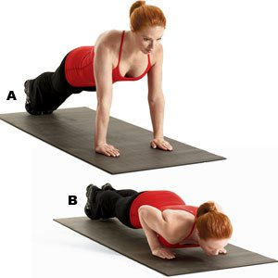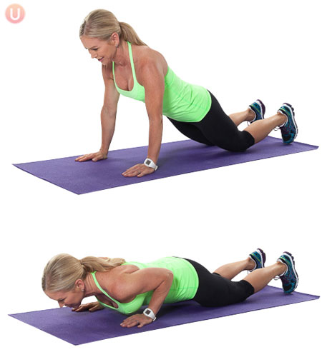
Upward-Facing Dog/Cobra
Downward Facing Dog
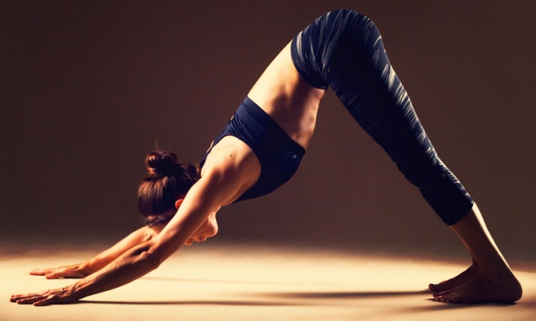

3 point Stretch
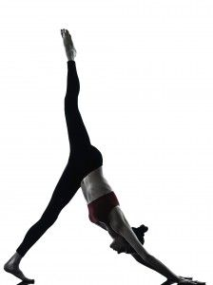

Warrior III
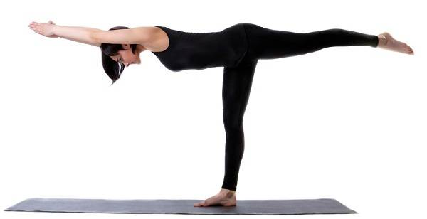

Plank

Benefits

The plank is one of the best exercises for core conditioning but it also works your glutes and hamstrings, supports proper posture, and improves balance

The plank is one of the best exercises for a flat, toned stomach because it works all the muscles in your core, including the rectus abdominals (the "six-pack muscles" you can see), transverse abdominals, internal and external oblique’s, hips, and back.

Standard Plank
1. Plant the hands directly under the shoulders (slightly wider than shoulder-width apart) like you’re about to do a push-up.
2. Ground the toes into the floor and squeeze the glutes to stabilize the body. Your legs should be working in the move too; careful not to lock or hyperextend your knees.
3. Neutralize the neck and spine by looking at a spot on the floor about a foot beyond the hands. Your head should be in line with your back.

Forearm Plank
This variation, also one of the most common ways to perform a plank, is slightly easier than holding the body up with just the hands. Place the forearms on the ground with the elbows aligned below the shoulders, and arms parallel to the body at about shoulder-width distance. If flat palms bother your wrists, clasp your hands together.

Knee Plank
This plank is noticeably easier to hold than the traditional straight-arm plank, making it great for beginner’s because it allows them to concentrate on form. By resting the knees on the ground, there’s less stress on the lower back.

Triceps push up on Toes/knees

Benefits
The Triceps Push up targets the pectorals, deltoids, and core muscles much like the traditional push up, but it more strongly engages the triceps when you use the narrow hand position.
The exercise positions all the muscles in our upper body and builds optimal strength in the forearms, shoulders and chest.
And for the ladies, they will “Get rid of the JIG” or “Bingo Wings”!!

These are done by getting into high plank and turning your fingertips outward slightly so your elbows are press into your sides (11am – 1pm). From there you will lower down keeping your elbows pointing back and close to your rib cage. These can be modified on your knees when starting out because they are difficult! , and only going half way to the floor.

Upward-Facing Dog/Cobra

Benefits
Strengthen the spine, arms and wrists, stimulate the organs of the abdomen, and improve posture by stretching anterior spine and strengthening posterior spine.
Stretch chest and lungs, shoulders and abdomen.

Begin lying on your belly with your legs extended straight back behind you and the tops of your feet relaxed down on the mat, hip distance apart.
- Plant your palms beside your ribs so that your elbows are bent approximately 90 degrees and your forearms are relatively perpendicular to the floor.
- On an inhale, press firmly into your palms and straighten your arms, lifting your torso, hips, and the tops of your thighs up off the ground. The shoulders should be stacked directly over the wrists and the creases of the elbows should face forward.
- Relax your shoulders away from your ears, and then begin to roll your shoulders back and find the action of pulling your chest forward through your upper arms. Keep the chin in line with the floor or lifted slightly, avoiding the urge to crank the head back in order to send the gaze up to the ceiling (which can compress the back of the neck).
- Drop onto your knees (Cobra) as a alternative (Knees & Toes on floor)

Downward Facing Dog
The Benefits:
Feel the difference this makes in your spine. If you have tight hamstrings, for the sake of your back you are far better to practice this pose with bent knees rather than force the heels down and compromise length in the spine.
Let your focus be spine first, heels down.

1. Hands should be shoulder distance apart.

2. Feet are hip distance apart.

3. Activate your arms and soften the elbows. As you press down through your wrists, feel the energy draw back up to activate your arms.

4. Keep your shoulders away from your ears, giving more space in the neck.

5. Neck and head continue along the same line as the spine it should follow the same natural line.

6. Firm shoulder blades and broaden across the upper back.

7. Engage the lower belly by drawing the navel in towards the spine. Draw the lower ribs in and keep this core activation going throughout the pose.

8. Bend knees a little (or a lot) and send the sit-bones and tailbone up and back.

9. Straighten legs without changing the shape in the spine or pelvis. Once you’ve reached this point, you can start to lengthen the heels back.

3 point Stretch

Benefits
3 Point Stretch Three has all of the same benefits as Downward Dog as well as; full-body stretching, strength building, energizing and rejuvenating the nervous system, relief from stress, headaches, fatigue, poor digestion, and back pain

- From a Downward dog position align your wrists directly under your shoulders
- Stretch your elbows and relax your upper back.
- Spread your fingers wide and press firmly through your palms and knuckles. Distribute your weight evenly across your hands.
- Step both feet together. Then, with your arms and legs straight, inhale and lift your right leg straight back and up, high in the air, pointing your toes and exhale.
- Keep your standing leg strong and your shoulders squared to the top of your mat. Imagine that your hands and heels are aligned along one straight, diagonal line. If you need to bend your supported leg and your extended leg to begin with.
- Keep your standing leg firm. Sink your standing heel toward the floor.
- Align your ears with your upper arms. Relax your head, but do not let it dangle. Gaze between your legs or toward your navel.

Warrior III Pose

Benefits
Strengthens the whole back side of the body, including the; shoulders, hamstrings, calves, ankles, and back. It also tones and strengthens the abdominal muscles. Warrior III improves balance, posture, and full-body coordination.
- Begin from a Low lunge or flight position

- Press your weight into your right foot. Lift your left leg as you lower your torso, bringing your body parallel to the ground. Your arms, still extended, will now reach forward or by your sides.
- Flex your left foot and reach out through your heel, as if you're pressing a wall behind you.
- Engage your core
- Keep the muscles of both legs actively engaged. Straighten your standing leg as you continue to lift the left leg, but do not lock your knees, keep these soft.
- Work toward bringing your arms, torso, hips, and raised leg parallel to the floor. You may need to lower the hip of your raised leg slightly in order to bring your hips parallel to your mat.
- Stretch your body from your fingertips all the way through your lifted heel and lengthen your spine.
- Gaze at the floor a few feet in front of your body.

