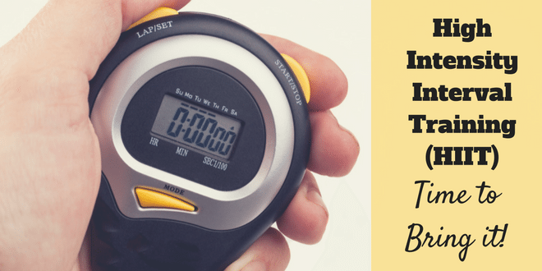
September 2017 - HITT

Low Impact Home HIIT Workout (Easy on the Knees) + 10min Abs’s Blast!!
5min warm up 30sec each exercise repeat twice though
- Forward jog and backwards- 4 forward 4 back
- Kick backs
- Squat reaches
- Reverse lunge jumps or keep low L&R
- Skaters
HIIT Workout 20min
20sec - work / 10sec – rest repeat 4 sets of each exercise
- Glut Bridge…. Get humpy lol…. Hamstrings & Gluts
- Punch, Punch, Knee lifts to opposite elbow engage abs…..
- Ankle touches…. Opposite arm to ankle… Arms - full stretch up!!
- Underarm punch x 3 kick
- Lunge Jumps or reverse lunges
- Triceps push ups fast
- Superman’s… lay on front lifting legs and chest off floor
- Front straight Punches with speed
- Over head punch with a slight light shuffle on feet
- Walkouts & press-ups on knees if needed
Abs’s Blast 10min
20sec work / 10sec rest - 2 sets on each one
- Sit ups feet on floor
- Knee reaches feet on floor
- Reach over’s feet off hands come down to floor
- Single leg reach straight leg in line with bent knee L & R
- Bicycle crunches slow elbow to knee
- Reverse crunch – shoulders on floor just legs lifting towards body
- Side plank either lifting hips up/down or hold still L & R
- Plank walk on knees or toes - forearms to standard plank
- Forearm plank on knees or toes knees to elbows or hold plank
- Climbing Beasts on knees or toes

