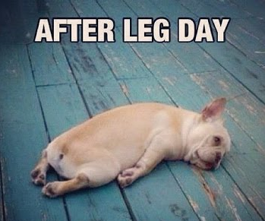
August 2017 – HITT Leg/Butt Workout
45sec - work / 15sec - rest
Repeat 4 sets of each exercise
4min warm up 20sec each exercise repeat twice though
- Boxer Shuffle side to side
- Bowlers L 1st set, R 2nd set with power arms
- Kick backs high or low
- Basic squats
- Reverse lunges L&R
- Alternate high knee lift - high or low impact
HIIT Workout
- Skaters fast
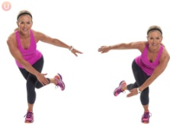
- Squat Reaches
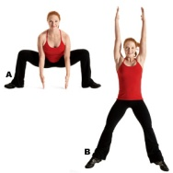
- Burpee Lunge or standing lunge connect - 2 x L 2 x R
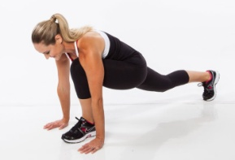
- Squat Adductor cross - 2 x L 2 x R
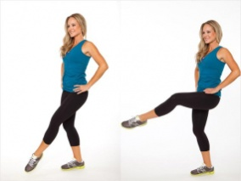
- Power Bowlers fast - 2 x L 2 x R

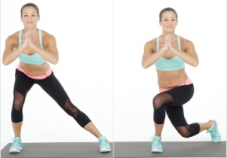
- Butt Lifts
- Climbing beasts on knees OR connects
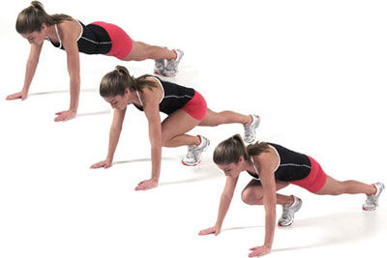
- Walk outs + 2 press ups - Omit walkouts as a alternative

