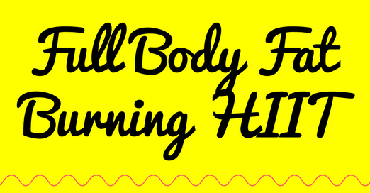
Post-Workout Calorie Burn: The Key to HIIT. The major reason that high-intensity interval training works so well to drop fat to a greater degree than continuous steady-state aerobic exercise appears to be the ability of all-out sprinting to boost your resting metabolism following a workout.
February 2018 - HIIT – Full Body Fat Burning
1st set - 40sec work - 20sec rest
2nd set - 30sec work – 30sec rest
3rd set – 20sec work – 10sec rest
Warm up & stretch
- Low squats + small jumps + forward punching arms
- Walkouts + 1 press up
- Shuffle steps - side to side + touch down
- From Sumo squat into SLOW Burpee - repeat
- Forearm to standard plank on toes/knees
- Squat + knee lift with elbow to opposite elbows – alternate L&R
- Plank to pike
- Reverse lunges to high knee lift alternate L&R
- Forward power lunges alternate L&R - FAST
- Sit up/knees bent on feet on floor – mimic climbing a rope keeping the core engaged

